House for Rent
Charming New England Colonial located in the Historic Five Corners District in Williamstown. Built in 1835, this newly painted home offers three bedrooms and two full baths, kitchen, living room, family room, dining room and porch. Working fireplaces in both the living room and family room. Brick patio off the family room with views of the mountain brook and perennial garden. Separate barn with electricity and ping pong table.

Facts and features
Year built: 1835
Lot: 164.00 acres
Type: Single Family Residential
Attached two car garage
Interior features
- Appliances: Oven, Stove, Refrigerator, Washer, Dryer, Security System, Freezer
- Basement: unfinished
- Flooring: Hardwood, Carpet
Building details
- Roof: Asphalt
- View: Mountain, Woodlands

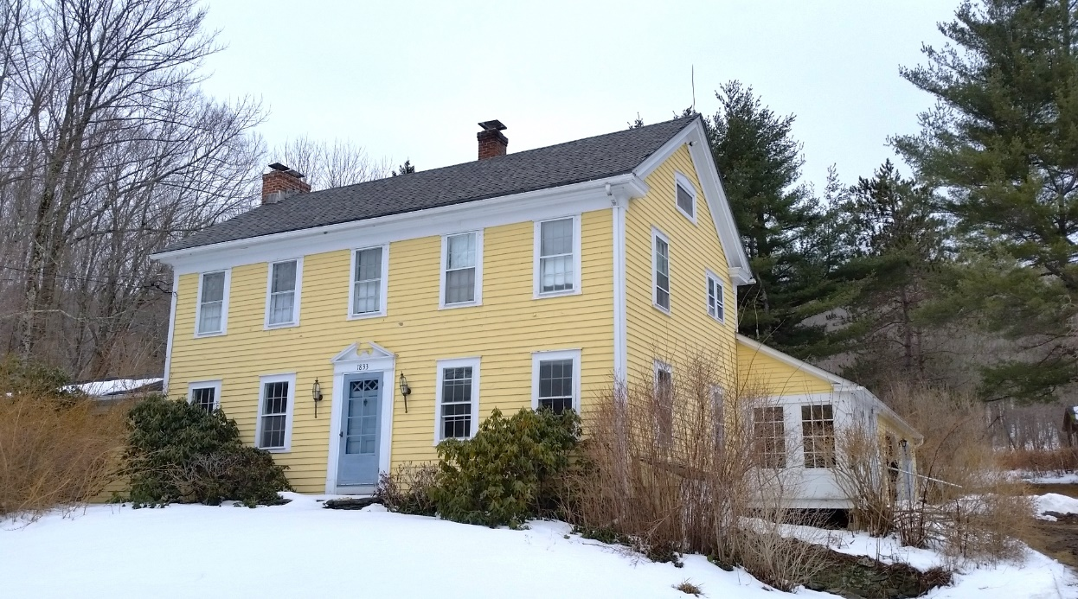

If interested please contact , Marla Curtis < marlagcurtis@gmail.com, subject Williamstown Rental
Annual rental -$1800 monthly, utilities not included.

